Driving & Parking Directions

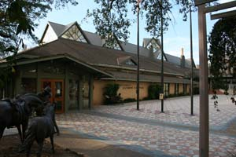

Driving Directions

Directions from Mopac (Loop 1) coming from the north: Take the Windsor Road exit. Turn right on to Windsor Road. Windsor Road turns into 24th Street. Take 24th Street to Guadalupe Street and turn left onto Guadalupe Street. Continue to the stoplight at W. Dean Keeton Street and turn right onto W. Dean Keeton Street. Continue to the stop light at San Jacinto Blvd and turn right onto San Jacinto. The IMHR parking will be on your right, in front of the UT Alumni Center.
Directions from Mopac (Loop 1) coming from the south: Take the Windsor Road exit. Turn left onto Windsor Road. Windsor Road turns into 24th Street. Take 24th Street to Guadalupe Street and turn left onto Guadalupe Street. Continue to the stoplight at W. Dean Keeton Street and turn right onto W. Dean Keeton St.. Continue to the stop light at San Jacinto Blvd and turn right onto San Jacinto. The IMHR parking will be on your right, in front of the UT Alumni Center.
Directions from I-35 coming from the north: Take Exit 235A University of Texas/MLK/15th Street. Turn right on MLK Blvd. Turn right on Trinity Street. Trinity merges with and turns into San Jacinto Boulevard. The IMHR parking will be on your left, in front of the UT Alumni Center.
Directions from I-35 coming from the south: Take Exit 235A University of Texas/MLK/15th Street. Take a left onto MLK Blvd. Turn right on Trinity Street. Trinity merges with and turns into San Jacinto Boulevard. The IMHR parking will be on your left, in front of the UT Alumni Center.

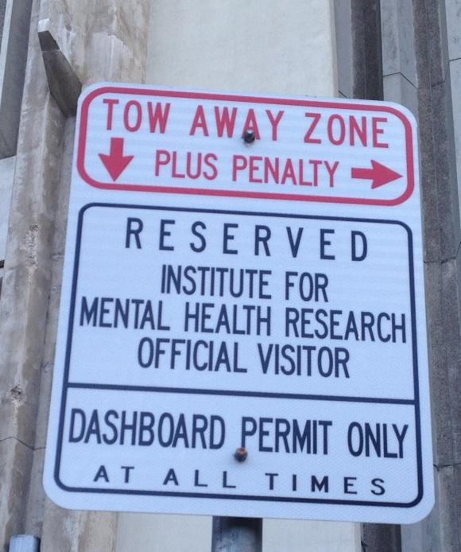

Parking: Please park in the reserved IMHR parking spots located along San Jacinto Blvd. in front of the UT Alumni Center opposite the football stadium. These parking spots are labeled “Reserved Institute for Mental Health Research Official Visitor: Dashboard Permit Only.” A research assistant will provide you with a dashboard permit upon your arrival and walk you to our facility.

