Allometry of the Present Moment
David L. Gilden and Taylor M. Mezaraups
University of Texas at Austin

Abstract
Central to human cognition is the experience of a subjective present moment, a moment that has a palpable span of a few seconds. We inferred spans of both children and adults, by measuring the slowest tempi that afforded rhythmic feel in drumming performance. It was found that taller people are capable of experiencing the feeling of rhythm at slower tempi than shorter people and also produce relatively more stable performances. Across the full height range of children and adults, there is a linear relationship between body size and the inferred duration of the present moment. Body size explains a much larger proportion of variance than typically found in cognitive assessments, suggesting that the present moment is governed by an allometric law.

Allometry of the Present Moment
There are at least two distinct points of departure for studying timing in animals. One is principally concerned with explicit judgment and begins with the observation that people and other animals can, in fact, judge time intervals, an interesting achievement in light of the obvious fact that there is no corresponding specific energy or sensory surface for its registration. For the most part, the theoretical issues that this observation raises have to do with the nature of time judgment in the range of seconds to tens of seconds. Many of the same issues that animated much of early sensory psychophysics have been recapitulated in the arena of time judgment (1-3).
The second point of departure concerns the implicit appearance of time in the organization of perception and action. Beyond issues of what people know about time and time intervals is the patent observation that the flux of moment-to-moment sensory stimulation is experienced within coherent and meaningful scenes and events. Underlying this experience are the processes of perceptual organization that affect temporal integration. Temporal integration is instrumental in making the passage of time coherent, and it is here that we encounter an observation of some significance: much of mental life is organized around a span of time encompassing a couple of seconds. The interval of 2±1 seconds is recognized as forming the subjective present moment (4,1), and it is also the duration of the action segments that comprise ordinary human activity (5). Like Miller’s 7±2 (6), the magnitude 2±1 (in seconds) plays a central role in human life, and the mere fact that it is a more or less definite quantity makes it interesting and invites investigation.
The work described here concerns the notion that the temporal span of 2±1 seconds be understood not as an interval of time but rather as a time scale (7), such that its magnitude has scaling properties that are set by the dimensions of the human body, properties that might be evident in the context of an appropriately designed experiment. In this sense, we inquire whether there is a kind of Kleiber Law for the size of “now”.

Operational Definition of the Present Moment
Quantitative measurement of the span of the present moment requires that this somewhat fuzzy idea be operationalized within specific methodologies, methodologies that produce dependent variables with meaningful metric properties. Here we operationalize the duration of the present moment in terms of constraints that underlie perceptual organization in time, specifically the feeling of rhythm that arises from discrete motor actions and the maximum pause length that may be bridged before it is disrupted. This maximum pause is effectively a temporal horizon for the emergence of rhythm, and it operationalizes the span of “now” in terms of a concrete and explicit dependent variable. The empirical issues all have to do with how temporal horizons are measured and whether they display body size dependence.
Drumming performance is well suited for the assessment of temporal horizons, because perceptual states within and beyond the horizon generate different signatures in the time series of inter-beat intervals. At relatively fast tempi (greater than say 60 beats per minute) the feeling of rhythm is reflected by a time series that fluctuates but is statistically stable. When a performance is attempted at a tempo that is too slow to sustain or create the feeling of rhythm, it is inevitable that the performance becomes meandering (8), leading to a time series resembling a random walk. In this way, an analysis of the time series of drumming performance permits a relatively straightforward assessment of the maximum time interval between beats that permits a sustained feeling of rhythm. This maximum time interval may be understood as an effective horizon for the feeling of rhythm, and it will be abbreviated throughout simply as t-horizon.

Empirical Assessment of Rhythmic Feel
This study investigated whether there is an allometric relation between body size and t-horizon, the slowest tempo at which a given person can experience the feeling of rhythm. The basic design of the experiment simply involved recording drum performances over a range of tempi and then deducing from the time series of drum strike intervals where each person exhibited rhythmic feel and where they appeared to be lost.
Drum performances from both children and adults were collected over a range of tempi (9). Each performance was analyzed in terms of the time series of inter-beat intervals, the time between successive drum strikes, with the objective of distinguishing competent drumming the state of being lost (8). The data analytic problem central to this work is illustrated in Figure 1, where we show a set of performances produced by a participant. (10) Plots identical to Figure 1 were constructed for all participants in order to facilitate discriminating Weberian growth of error that is expected in regimes of stable performance from truly wandering performances. In this example, the performer appears to be competently drumming with Weberian error growth between 80 bpm and 55 bpm; that is, their error is increasing in proportion to the inter-beat interval and remains relatively stable. At 50 bpm, a low frequency wave begins to dominate the time series, a feature not exemplary of stable drumming performance. At tempi of 45 and 40 bpm, the performance is manifestly wandering and erratic. As 55 bpm is the last tempo at which this person executed a stable performance, we judge the inter-beat interval corresponding to this tempo (1.1 seconds) to be their temporal horizon, the maximum time interval over which they can achieve the temporal integration requisite to experience the feeling of rhythm.
The temporal horizons for the feeling of rhythm are aggregated for both children and adults in Figure 2, as a function of the performer’s height. The relationship between temporal horizon and height is evidently linear; t-horizon ~ height^{1.15±0.1}. The correlation coefficient is so large that the magnitude alone requires interpretation. A correlation of 0.71 is unexpected in the context of cognitive assessment, as it entails that over 50% of the variance in t-horizon is captured by height. Designed studies in mainstream cognitive psychology, such as might be encountered in visual search, lexical decision, mental rotation, etc., typically have treatment effects that account for only 10% of the variance (11). Body size is so effective at organizing the outer limits of rhythmic experience that it is apparent we are looking at a relation that is not so much psychological as it is biological. In other words, the effect size itself suggests that we are looking at a kind of Kleiber Law for the span of the present moment. (12)
In the course of executing performances at various tempi, every participant at some point managed to produce a couple of stable performances. Having the data, we wondered whether drumming accuracy might also display an allometry with body size. The results are shown in Figure 3, where the log coefficient of variation (cv=standard deviation/mean) of the interbeat intervals at 70 bpm are displayed in relation to the log height of the drummer. The implied relation is cv ~ height^{2.1±0.1}. As in the analysis of t-horizon, we find that the regression yields a high degree of correlation, -.5, implying that 25% of accuracy variability is explained by height. Again, the child and adult data appear to align continuously along the regression line – suggesting that the principal difference between children and adults in drumming accuracy is just body size. (13)
These results should be put into the context of an earlier and more extensive set of developmental studies of rhythm conducted by Drake et al. (14). In one of the many experiments they conducted was a condition where participants were instructed to freely produce the slowest rhythm possible. The motivation for such an instruction was essentially that which informs our study - to estimate t-horizon, the maximum temporal span that permits integration of time based sequences into coherent scenes. Drake et al. found that older children attempted slower rhythms than younger children. This is quite in agreement with our finding that t-horizon increases with height – as far as children are concerned; however, Drake et al. regard their finding as being essentially about development and aging, and in fact, they represent the adults in their study by a single point – the tacit understanding being that adulthood is the end of childhood development. As we have made clear, we regard height as being the controlling variable, and the evidence for this is that children and adults are seen to lie on a common law when adult height variation is reflected in the data. Were it not for the adult data, we would be left with an intractable age-height confound.
In summary we have demonstrated two previously unknown allometries that govern feeling of rhythm; a body size relation for the slowest tempo that permits rhythmic feel that is linear, and a body size relation for the accuracy of drumming performance that is quadratic. We interpret the first result in terms of the span of the subjective present and propose that this span is a biological quantity in the same sense as heartrate and respiration rate.

References and Notes
- Fraisse, P. (1984). Perception and estimation of time. Annual Review of Psychology, 35, 1-36.
- Allan, L. G. (1979). The perception of time. Perception and Psychophysics, 26, 340-354.
- Wearden, J. H. (1991). Do humans possess an internal clock with scalar timing properties? Learning and Motivation, 22(1), 59-83.
- Pöppel, E. (1997). A hierarchical model of temporal perception. Trends in cognitive sciences, 1(2), 56-61.
- Schleidt, M., Eibl-Eibesfeldt, I., & Pöppel, E. (1987). A universal constant in temporal segmentation of human short-term behavior. Naturwissenschaften,74(6), 289-290.
- Miller, G. A. (1956). The magical number seven, plus or minus two: some limits on our capacity for processing information. Psychological review, 63(2), 81.
- The quantities judged in time estimation tasks are just intervals of time, nothing more, and these intervals may take on a range of values extending into the many tens of seconds. Time scales, however, are not targets in this sense and are may not be chosen to accommodate an experimental design. Time scales rather reflect some piece of physics or biology that dictates that a particular value is observed. The value observed is, of course, a time interval, but lurking behind it, is an edifice of physical interaction that creates it in the first place. In this sense time scales such as crossing times, relaxation times, and decay times are functions of system parameters, not fixed quantities.
- Gilden, D. L., & Marusich, L. R. (2009). Contraction of time in attention-deficit hyperactivity disorder. Neuropsychology, 23(2), 265.
- Materials and methods are available as supplementary materials at the Science website.

- In this study, the authors, along with an assistant, assessed each time series as to whether it showed signatures of rhythmic feel. The performances were labeled in such a way that judges were blind to any height information. In practice, assessments of the slowest tempo showing rhythmic feel between judges did not differ by more than 5 bpm. In previous work we have relied upon the autocorrelation function and related measures to discriminate wandering from stable drumming (8) but in the present study have relied upon visual analysis to assess the slowest stable performance. That a human judge might be more sensitive to time series structure than statistics based on autocorrelation is well known (15): what an image looks like is principally determined by the phase spectrum, the power spectrum contributing very little to image recognition. When a person looks at a time series, they are aware of and sensitive to signatures derived implicitly from the phase spectrum – intermittent features, chains, and other patterns involving 3 or more time series samples.
- Gilden, D. L. (2001). Cognitive emissions of 1/f noise. Psychological review,108(1), 33.
- As far these data are concerned, the principal difference between children and adults is that children are generally shorter. Despite the manifold developmental differences between children and adults, in this study, both populations are well described by the same linear relation. This conclusion is reinforced by analysis of the residuals once height is removed as an effect. In the raw t-horizon measurements, there is a difference of .31 seconds in temporal horizon between children and adults. When the effect of height is removed, this difference collapses to .06 seconds, a significant difference in light of the large sample size [t (130) = 2.22, p < .014)].
- Prior to height being removed as a regressor, there is a 3.4% difference between children and adults in their coefficients of variation, a large difference, comparable to that between adults with no musical training and adults who are professional drummers (unpublished data). Once height is removed, this difference collapses to 1%, significant (t (129) = 2.1, p < .02) but nevertheless quite small. Again, regardless of the many differences that exist between children and adults beyond body size, being a child in and of itself contributes little to variation in drumming accuracy.
- Drake, C., Jones, M. R., & Baruch, C. (2000). The development of rhythmic attending in auditory sequences: attunement, referent period, focal attending. Cognition, 77(3), 251-288.
- Piotrowski, L. N., & Campbell, F. W. (1982). A demonstration of the visual importance and flexibility of spatial-frequency amplitude and phase. Perception, 11(3), 337-346.
- Agutter, P. S., & Wheatley, D. N. (2004). Metabolic scaling: consensus or controversy? Theoretical Biology & Medical Modelling, 1, 13. http://doi.org/10.1186/1742-4682-1-13.
- Johnstone, A. M., Murison, S. D., Duncan, J. S., Rance, K. A., & Speakman, J. R. (2005). Factors influencing variation in basal metabolic rate include fat-free mass, fat mass, age, and circulating thyroxine but not sex, circulating leptin, or triiodothyronine. The American journal of clinical nutrition, 82(5), 941-948.
- Fleming, S., Thompson, M., Stevens, R., Heneghan, C., Plüddemann, A., Maconochie, I., & Mant, D. (2011). Normal ranges of heart rate and respiratory rate in children from birth to 18 years of age: a systematic review of observational studies. The Lancet, 377(9770), 1011-1018.
- Kuczmarski, R. J., Ogden, C. L., Grummer-Strawn, L. M., Flegal, K. M., Guo, S. S., Wei, R., ... & Johnson, C. L. (2000). CDC growth charts: United States. Advance data, (314), 1-27.
- Rose, J., Ralston, H., & Gamble, J. (1994). Energetics of walking. Human Walking, 45-72.
Acknowledgments

Author Note
David L. Gilden, Department of Psychology, University of Texas at Austin; Taylor M. Mezaraups, Department of Psychology, University of Texas at Austin.
We thank Lydia M. Crooks for her assistance in collecting and analyzing data. We thank Jesse L. Martz for helping in the collection of data. We thank Aimee Zivin and Sean Fitzsimmons at St. Andrew’s Episcopal School for allowing us to collect data from children in the afterschool program, Beyond the Classroom (BTC).
Correspondence concerning this article should be addressed to David L. Gilden, Department of Psychology, University of Texas at Austin, 108 E. Dean Keeton Stop A8000, Austin, Texas 78712. E-mail: dgilden@utexas.edu

Figure Captions
Figure 1. Time series of interbeat intervals from a single participant. The transition point between Weberian growth in error and meandering (temporal horizon) occurs for this individual at 55 bpm.
Figure 2. Temporal horizons for the feeling of rhythm in children and adults, as a function of performer height.
Figure 3. Coefficients of variation for drumming performance at 70 bpm, as a function of performer height.

Figure 1
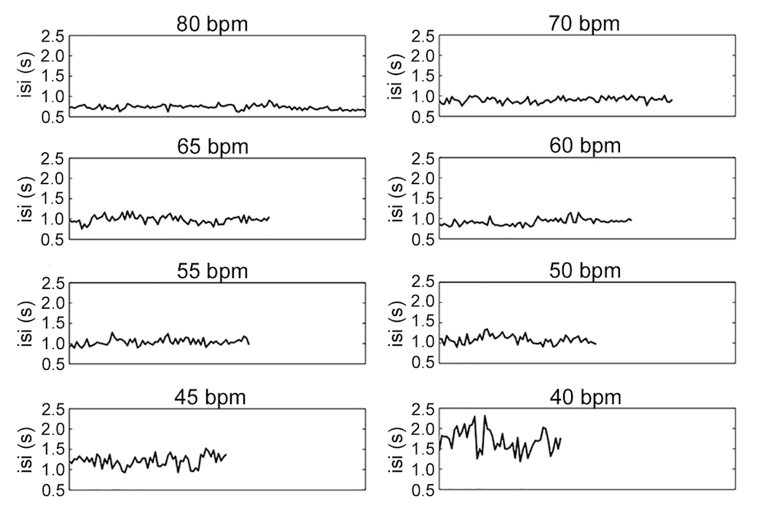

Figure 2
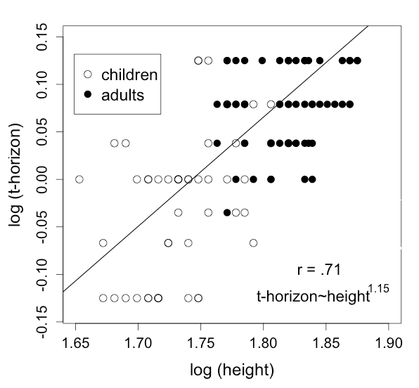

Figure 3
